|  |  |  |
| --- | --- | --- |
| Force: | Acts on: | Force-carrier particle: |
| Strong nuclear force | Hadrons | Gluon |
| Electromagnetic force | Charged particles | Photon |
| Weak nuclear force | Quarks and leptons | W+, W– and Z0 bosons |
| Gravity | All particles | “Graviton” |

|  |  |
| --- | --- |
| Particle: | Consists of: |
| Baryon | 3 quarks |
| Meson | 2 quarks (quark/antiquark pair) |
| Rules:   * Charges must balance. * For baryons, baryon number must add to +1 and antiparticles to –1. * For mesons, baryon number must add to 0. | |

**Standard Model**

Main points:

* Currently the most complete explanation of the fundamental particles and interactions.
* The standard model is based on the premise that all matter in the universe is made up from elementary matter particles called quarks and leptons.
* Quarks experience the strong nuclear force while leptons don’t.
* The world is made up of 6 quarks and 6 leptons. Everything we see is a conglomeration of quarks and leptons.
* Baryons are composite particles made up of quarks.
* A particle’s state (set of quantum numbers) can affect how it interacts with other particles.
* Lepton number and baryon number are conserved in all reactions between particles.
* There are 4 fundamental forces and force-carrier particles are associated with each force.
* The standard model explains $\frac{3}{4}$ fundamental forces (strong, weak and electromagnetic) in terms of an exchange of force-carrying particles called gauge bosons. Each force is mediated by a different type of gauge boson.
* High-energy particle accelerators are used to test theories of particle physics.
* The magnitude of the force experienced by a particles travelling in a magnetic field depends on the charge and velocity of the particle and the strength of the field.

Pauli Exclusion Principle:

* Physicists once thought that no 2 particles in the same quantum state could exist in the same place at the same time. This explains much about chemistry.
* Certain particles don’t obey this principle – these are called bosons, and those that do are called fermions.

Imagine a large family of identical fermion siblings spending the night at the Fermion Motel and another large family of identical boson siblings spending the night at the Boson Inn. Fermions behave like squabbling siblings and not only refuse to share a room, but also insist on rooms as far as possible from each other. On the other hand, boson siblings prefer to share the same room.

Fermions and bosons:

* Fermions are the matter particles consisting of 6 quarks and 6 leptons. They all obey the Pauli Exclusion Principle, and all have an antiparticle.
* A fermion is any particle whose spin is an odd half-integer.
* Quarks and leptons, as well as most composite particles e.g., protons and neutrons, are fermions.
* Having an odd half-integer spin means fermions obey the Pauli Exclusion Principle (2 fermions can’t coexist in the same state and location at the same time).
* Bosons have an integer spin.
* All force-carrier particles are bosons, as are those composite particles with an even number of fermions e.g., mesons.

Matter and antimatter:

* For every type of matter particle we know there exists a corresponding antimatter particle/antiparticle.
* The antiparticle is identical in mass to the particle from which it derives its name but opposite in sign.
* Antiparticles behave just like their corresponding matter particles except they have opposite charges.
* Wen a matter particle and antimatter particle meet, they annihilate into pure energy.
* Up quark “u” → up antiquark “ū”.
* Electron “e–“ → positron “e+”.

Quarks:

* There are 6 quarks.
* Quarks are never found alone but as specific combinations of 2 or 3 in particles called hadrons.
* 3 quarks having a charge of + $\frac{2}{3}$ are called up, charm and top, and 3 having charge $–\frac{1}{3}$ are called down, strange and bottom.
* The up and down quarks together account for both the charge and neutron.
* There are 3 pairs of quarks: up/down, charm/strange and top/bottom.

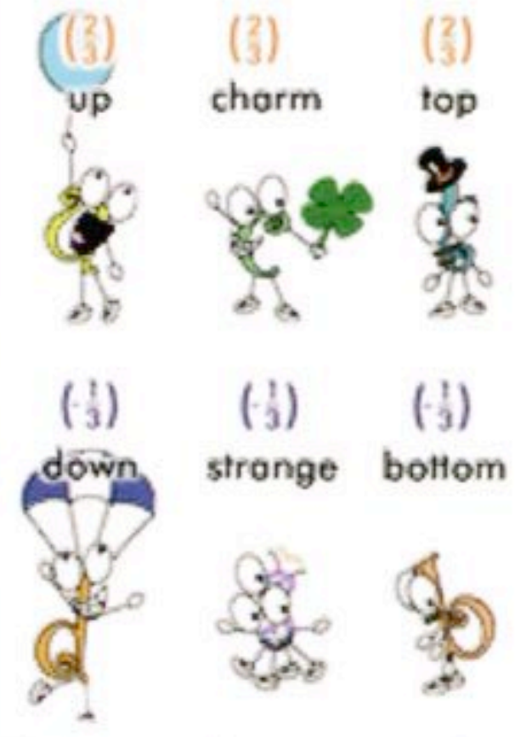

Hadrons:

* Hadrons are composite particles made up of 2 or more quarks, are capable of existing on their own (as opposed to in combination) and can interact strongly with each other.
* Quarks only exist in groups with other quarks and are never found alone.
* Only a very small part of the mass of a hadron is due to the quarks in it.
* Individual quarks combine such that hadrons have a net integer electric charge.
* Hadrons have no net colour charge even though the quarks themselves have it.
* Interacts through the strong nuclear force.

There are 2 classes of hadrons – baryons and mesons:

* A baryon is any hadron made up of 3 quarks (qqq). Protons are baryons, made up of 2 up quarks and one down quark (uud). So are neutrons (udd).
* A meson is a hadron made from a quark and its antiquark e.g., pion (+) which is made of an up quark and a down antiquark). The antiparticle of a meson just has the quark and antiquark switched, so an antipion (–) is made of a down quark and an up antiquark.
* Mesons are very unstable.
* The K meson lives much longer than most mesons hence the name “strange” was given to the strange quark, one of its components.

3 different quarks → baryon e.g., nucleons (p, n) and hyperons (λ+, λ0, Ω–, etc).

Quark and anti-quark pair → mesons e.g., pion-plus (π+) and kaon-plus (K), etc.

Some conservation rules:

* Charges must balance e.g., charges on the 3 quarks of a proton must add to +1.
* Baryon number for baryon particles must add to +1 and for antiparticles –1.
* Baryon number for mesons must add to zero.

Leptons:

* There are 6 leptons, 3 electrically charged and 3 neutral.
* Leptons appear to be point-like particles without internal structure and hence fundamental.
* Charged leptons: electron, muon and tau.
* Neutral leptons are the neutrinos (no electrical charge, very little mass and very hard to detect).
* Each pair of leptons is intimately connected to a pair of quarks – the electron and its neutrinos are connected to the up and down quarks, the muon and its neutrino to the strange and charm quarks and the tau and its neutrino to the top and bottom quarks.
* Leptons are solitary particles. Each lepton has a corresponding antilepton.
* The heavier leptons (muon and tau) aren’t found in ordinary matter because when they’re produced thy very quickly decay/transform into lighter leptons.
* Sometimes the tau lepton will decay into a quark, an antiquark and a tau neutrino. Electrons and the 3 kinds of neutrinos are stable.
* When a heavy lepton decays, one of the particles it decays into is always its corresponding neutrino. The other particles could be a quark and its antiquark, or another lepton and its antineutrino.
* To explain why some types of lepton decays are possible and some aren’t, physicists divided the leptons into 3 lepton families: the electron and its neutrino, the muon and its neutrino and the tau and its neutrino. The number of members in each family must remain constant in a decay.
* A particle and an antiparticle in the same family “cancel out” to make the total of them equal to zero. Although leptons are solitary, they’re always loyal to their families.
* Interacts through the weak nuclear force.

Lepton type conservation:

* “Electron/muon/tau number” refers to the lepton family of a particle.
* Electrons and their neutrinos have electron number +1.
* Positrons and their antineutrinos have electro number –1.
* All other particles have electron number 0.
* Muon number and tau number operate analogously with the other 2 lepton families.
* Electron/muon/tau number are always conserved when a massive lepton decays into smaller ones.

A muon decays into a muon neutrino, electron and electron antineutrino:

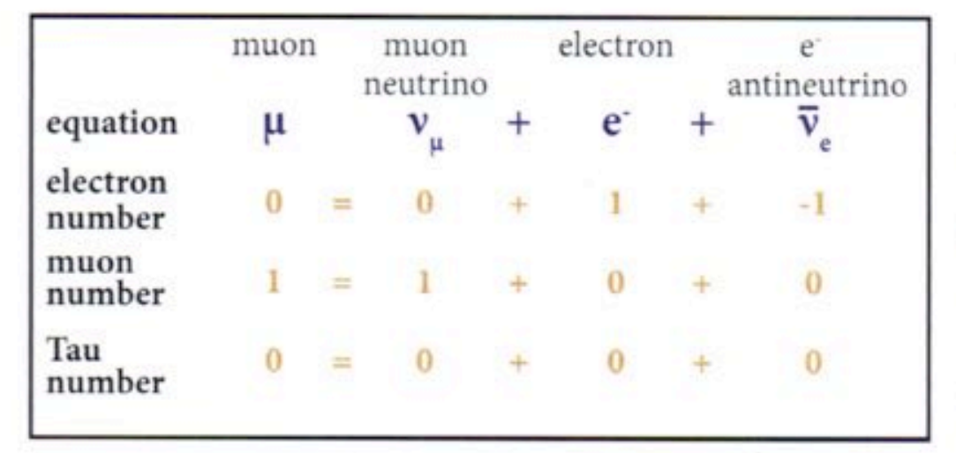

Electron, muon and tau numbers are conserved.

Neutrinos:

* Neutrinos are a type of lepton.
* They have no electrical charge or strong charge and hence almost never interact with any other particles. Most neutrinos pass right through the earth without ever interacting with a single atom of it.
* Beta minus decay produces an antineutrino.
* Beta plus decay produces a neutrino.
* Neutron → proton + electron + antineutrino.

Gauge bosons:

* Gauge bosons are massless and are referred to as the force-carriers since they’re the particles responsible for mediating the strong and weak interactions.
* Particles subject to either the strong or weak interaction exchange bosons as they interact.
* The W-positive, W-negative and Z0 mediate the weak interactions between the different flavours of quarks and leptons.
* The 8 gluons mediate the strong force between the quarks and the photon mediates the electromagnetic interaction.

Photons:

* Photons are different because they don’t have a rest mass and travel at the speed of light.
* Depending on its energy, a photon can be transformed into a particle/antiparticle pair. Conversely, a collision between a particle and its antiparticle will result in the annihilation of those particles and the formation of photons.

Flavour:

* Flavour is a property that separates the different types of leptons and quarks.
* Each of the charged lepton and its associated neutrino has a distinct flavour, as do the 3 flavours of quarks, with 2 flavours for both.
* The first flavour of both leptons and quarks (electrons, protons and neutrons) doesn’t undergo decay, with the electrons orbiting the atomic nuclei containing the protons and neutrons which are composed of up and down quarks.
* The second flavour (charm and strange quark; muon and muon neutrino) and third flavour (top and bottom quark; tau and tau neutrino) have short half-lives and are only observed in very high energy particle accelerators.
* The masses of the particles in each successive flavour are greater than that of corresponding particles in the flavour before. This is why successive flavours were discovered only when more powerful particle accelerators were built.

Fermions:

|  |  |  |  |  |  |  |  |
| --- | --- | --- | --- | --- | --- | --- | --- |
| Leptons (spin = $\frac{1}{2}$) | | | | Quarks (spin = $\frac{1}{2}$) | | | |
| Name: | Symbol: | Charge: | Lepton number: | Flavour: | Symbol: | Charge: | Baryon number: |
| Electron | e | –1 | 1 | Up | u | $$\frac{2}{3}$$ | $$\frac{1}{3}$$ |
| Electron-neutrino | ve | 0 | 1 | Down | d | $$-\frac{1}{3}$$ | $$\frac{1}{3}$$ |
| Muon | µ | –1 | 1 | Charm | c | $$\frac{2}{3}$$ | $$\frac{1}{3}$$ |
| Muon-neutrino | vµ | 0 | 1 | Strange | s | $$-\frac{1}{3}$$ | $$\frac{1}{3}$$ |
| Tau | τ | –1 | 1 | Top | t | $$\frac{2}{3}$$ | $$\frac{1}{3}$$ |
| Tau-neutrino | vτ | 0 | 1 | Bottom | b | $$-\frac{1}{3}$$ | $$\frac{1}{3}$$ |

The 4 interactions:

* The 4 fundamental interactions between particles are attractive forces, repulsive forces, decay and annihilation.
* All forces in the world can be attributed to these 4 interactions.
* Interactions that affect matter particles arise form an exchange of force-carrier particles, a different type of particle altogether.
* A particular force-carrier particle can only be absorbed or produced by a matter particle which is affected by that particular force.
* e.g., protons and electrons have electric charge so they can produce and absorb the electromagnetic force carrier, the photon; neutrinos, on the other hand, have no electric charge, so they can’t absorb or produce photons.

Feynman diagrams:

* Solid lines represent matter particles, fermions, and the wiggly or dashed lines the force carriers, bosons.
* Lines meet at a point (vertex) which represents the interaction.
* If we imagine 2 protons approaching each other, the repulsive force occurs through the continual exchange of photons. As the photons get closer, the exchange of these photons becomes more rapid and the force increases.
* The photons exchanged between the interacting particles have a very brief lifespan and are essentially “virtual” photons.

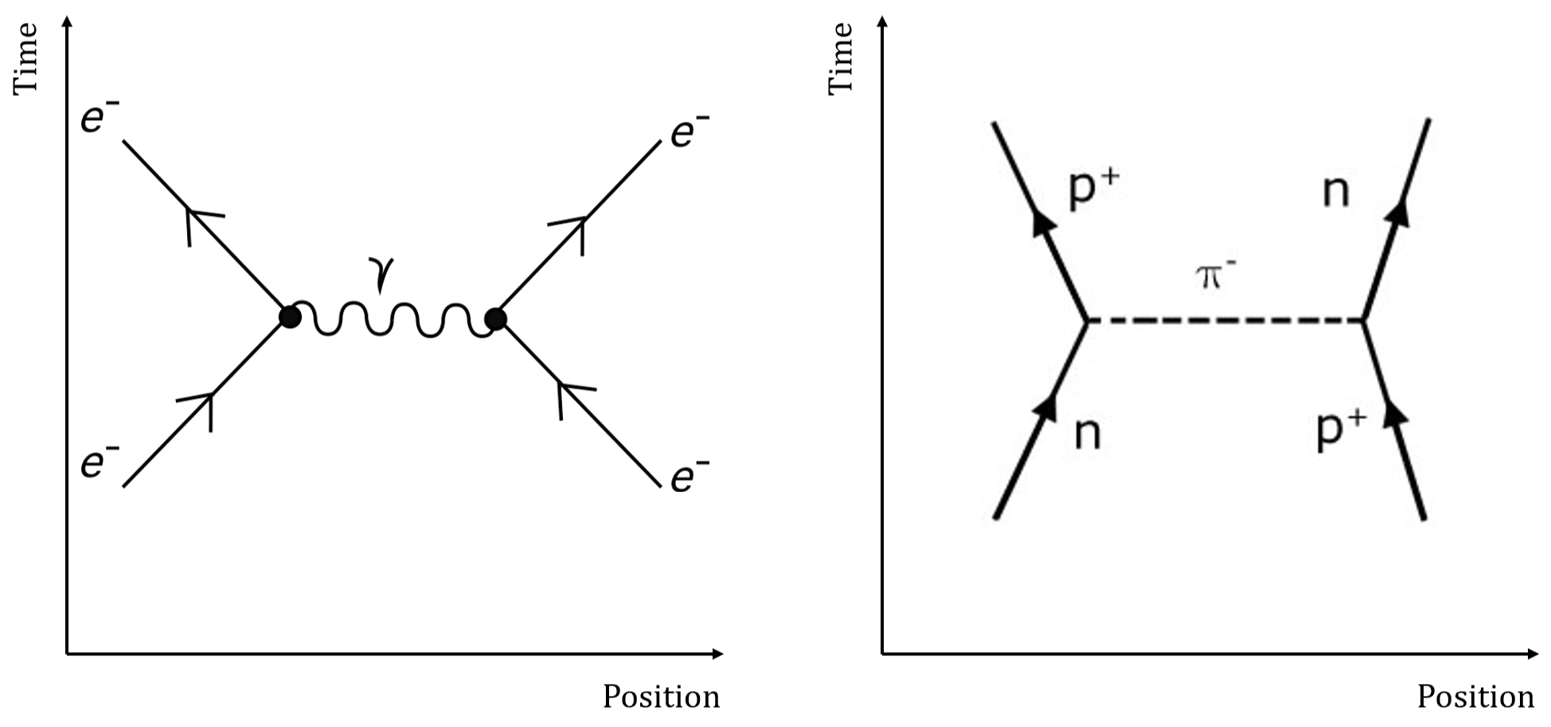

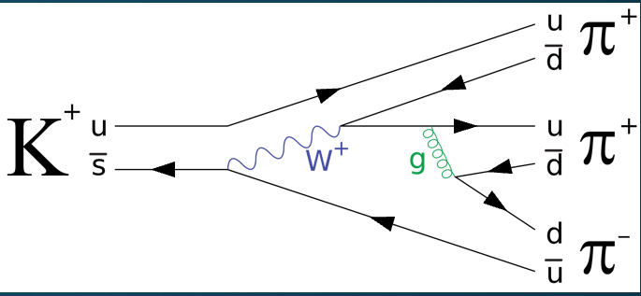

The electromagnetic force:

* It causes like-charged things to reel and oppositely-charged things to attract.
* Many everyday forces e.g., friction and magnetism are caused by the electromagnetic force. The force that keeps you from falling through the floor is the electromagnetic force which causes the atoms making up the matter in your feet and the floor to resist being displaced.
* The carrier particle of the electromagnetic force is the photon.
* The charged parts of one atom can interact with the charged parts of another, allowing different atoms to bind together, an effect called the residual electromagnetic force.

The strong nuclear force:

* Quarks have electromagnetic charge and they also have an altogether different kind of charge called colour charge.
* The force between colour-charged particles is very strong so it’s called the “strong force”.
* The strong force holds quarks together to form hadrons, so its carrier particles are called gluons (they glue quarks together).

Colour:

* Colour/colour charge refers to the 3 states of quarks called red, blue and green.
* Antiquarks are labelled anti-red, anti-blue and anti-green.
* Gluons that hold quarks together are also coloured.
* When a gluon is emitted or absorbed by a quark, the quark may change colour (state) but the large composite particle is always colourless.
* To be colourless, baryons (protons and neutrons) are comprised are of 3 quarks and must therefore have one of each colour. Mesons are comprised of 2 quarks and must comprise of a quark/antiquark pair.

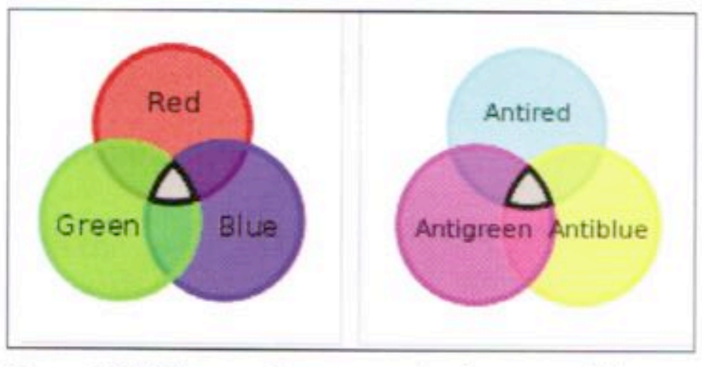

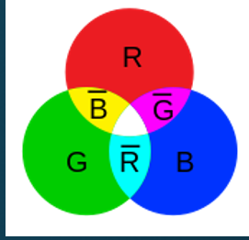

* Quarks and gluons are colour-charged particles. They exchange gluons in strong interactions.
* When 2 quarks are close to one another, they exchange gluons and create a very strong colour force field that binds the quarks together. The force field gets stronger as the quarks get further apart.
* Quarks constantly change their colour charges as they exchange gluons with other quarks.
* Each quark has one of the 3 colour charges and each antiquark has one of the 3 anti-colour charges
* Red + blue + green = colour neutral.
* Anti-red + anti-blue + anti-green = colour neutral.
* Mesons are colour neutral since they carry combinations e.g., red and anti-red.
* Because gluon-emission and gluon-absorption always changes colour and colour is a conserved quantity, gluons can be thought of as carrying a colour and an anti-colour charge.
* There are 8 possible colour-anti-colour combinations.
* Colour-charged particles can’t be found individually so the colour-charged quarks are confined in groups (hadrons) with other quarks. These composite particles are colour neutral.
* Only baryons (3 different colours) and mesons (colour and anti-colour) are neutral. Particles e.g., ud or uddd that can’t be combined into colour neutral states are never observed.

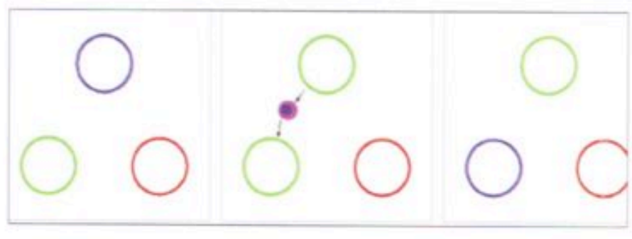

A: A hadron with 3 quarks (red, green and blue) before a colour change.

B: Blue quark emits a blue-anti-green gluon.

C: Green quark has absorbed the blue-anti-green gluon and is now blue; colour remains conserved.

Residual strong force:

* The strong force binds quarks together because quarks have colour charge.
* The strong force between the quarks in one proton and the quarks in another proton is strong enough to overwhelm the repulsive electromagnetic force.
* This is called the residual strong interaction.

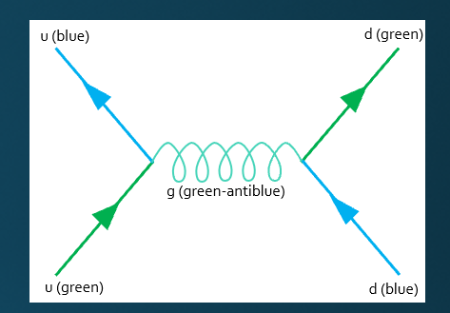



The weak force:

* Weak interactions are responsible for the decay of massive quarks and leptons into lighter quarks and leptons.
* When fundamental particles decay, some of the original particle’s mass is converted to kinetic energy and the resulting particles always have less mass than the original particle that decayed.
* The only matter around us that’s stable is made up of the smallest quarks and leptons which can’t decay any further.
* When a quark or lepton changes type (e.g., a muon changing to an electron) it’s said to change flavour.
* All flavour charges are due to the weak interaction.
* The carrier particles of the weak interactions are the W+, W– and Z particles. The W’s are electrically charged, and the Z is neutral.

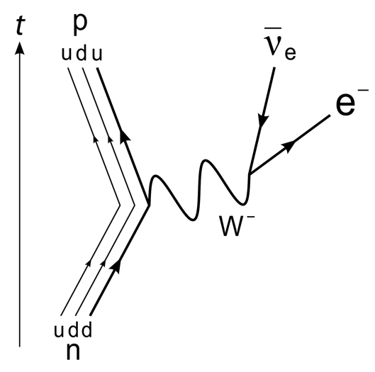

|  |  |  |
| --- | --- | --- |
| **Interaction**: | **Acts on**: | **Mediating particle**: |
| Strong nuclear | Hadrons | Gluons |
| Electromagnetic | Charged particles | Photon |
| Weak nuclear | Quarks and leptons | W+, W– and Z0 particles |
| Gravitational | All particles | Graviton (not observed) |

|  |  |  |  |  |
| --- | --- | --- | --- | --- |
| **Interaction**: | **Acts on**: | **Responsible for**: | **Range**: | **Mediating particle**: |
| Strong nuclear | Hadrons | Binding quarks together to form hadrons.  Binding hadrons together to form nuclei. | Short | Gluons |
| Electromagnetic | Charged particles | Binding electrons to nuclei to form atoms.  Binding atoms together to form molecules/lattices.  Chemistry, electronics, light, etc. | Long | Photon |
| Weak nuclear | Quarks and leptons | Mediating beta decay and other interactions including neutrinos. | Short | W+, W– and Z0 particles |
| Gravitational | All particles | Forming stars, planets, blackholes, galaxies, etc. | Long | Graviton (not observed) |

|  |  |  |  |
| --- | --- | --- | --- |
| Fermions  Matter particles; spin = $\frac{1}{2}$, $\frac{3}{2}$, $\frac{5}{2}$, … | | Bosons  Force carriers; spin = 0, 1, 2, 3, … | |
| Leptons & Quarks  Spin = $\frac{1}{2}$ | | Gauge Bosons  Spin = 1 | Higgs Boson  Sin = 0 |
| Leptons  6 favours: e, ve, µ, vµ, τ, vτ | Quarks  6 flavours:  Up, down, charm, strange, top, bottom | Electroweak interactions – photons  W+, W–, Z0 particles  Strong interactions – gluons | A particle consistent with a Higgs boson was first detected in 2012 and confirmed in 2013 |

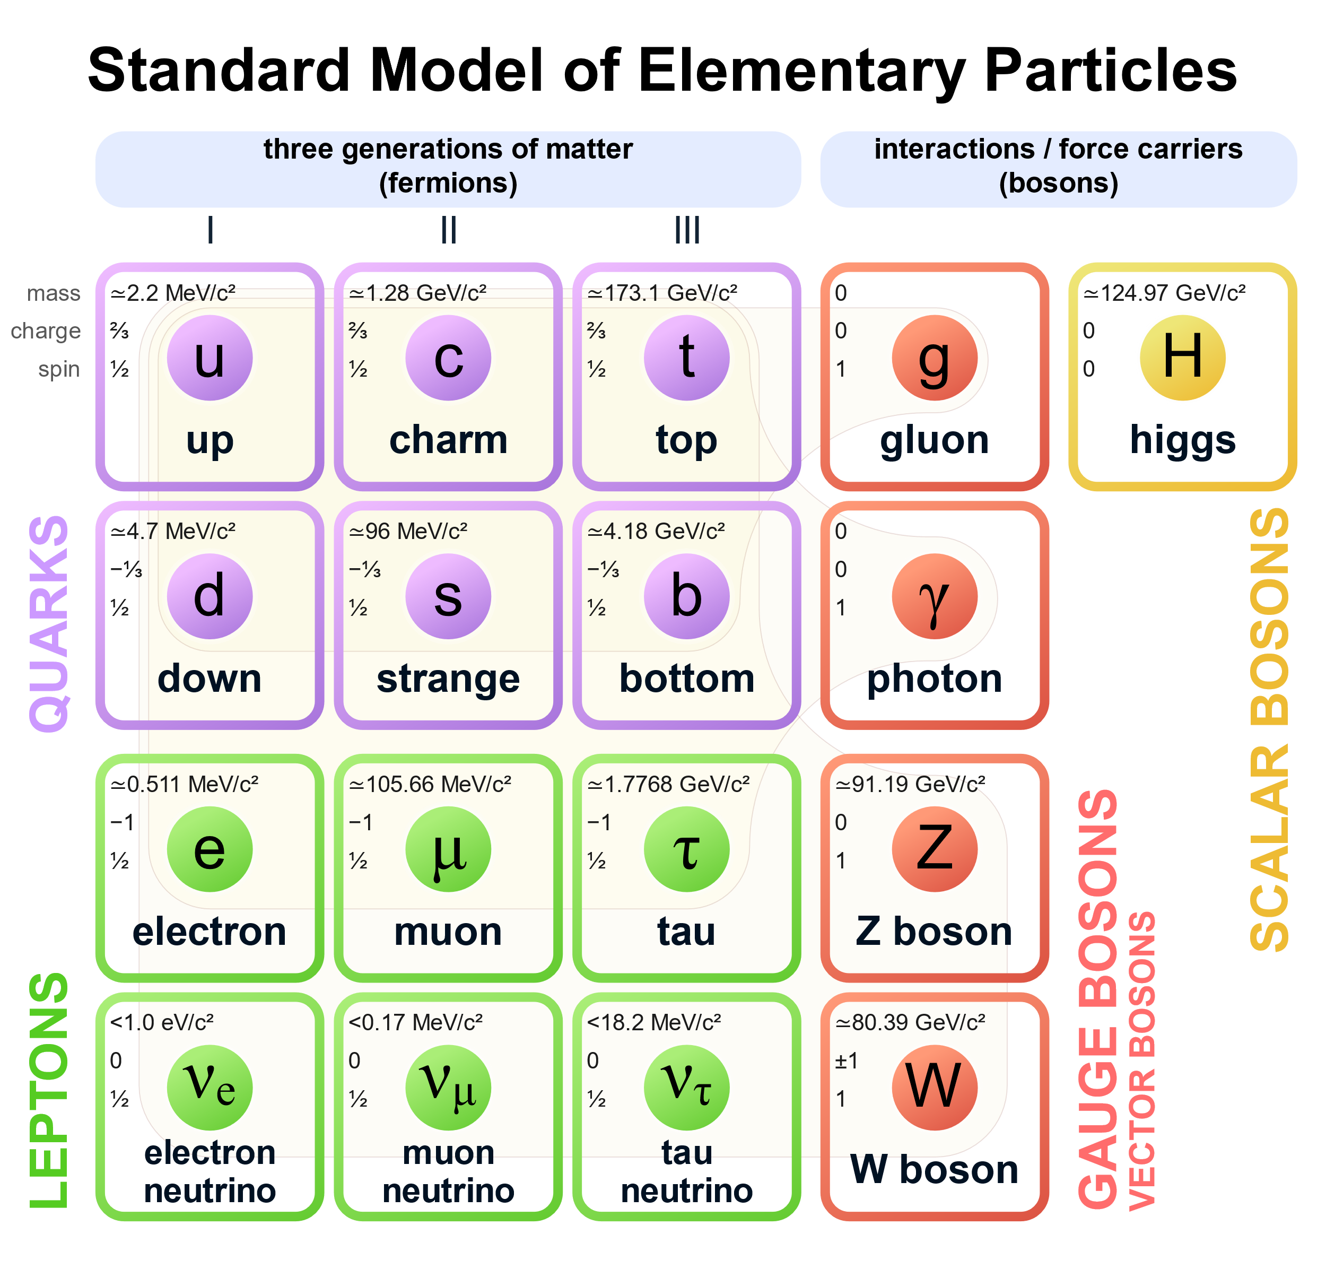

Weak and gravity interactions act on neutrinos.

Weak (W+, W– and Z) interactions have heavy carriers

All interactions act on you.

Friction is caused by residual electromagnetic interactions between the atoms of the two materials. The force carriers are photons and W and Z bosons.

Nuclear bonding is caused by residual strong interactions between the various parts of the nucleus. The force carriers are gluons.

The planets orbits due to gravitons.

Big Bang theory:

* Using mathematical modelling and the measured velocities of receding galaxies, the Big Bang theory suggests tat the universe expanded from an infinitely dense single point some 13 billion years ago.
* In 1912 Vesto Slipher used spectroscopic analysis of a distant spiral nebula and found that the spectral lines were all closer to the red end of the spectrum. This red shift indicates that the nebula was moving away from the Milky Way.
* In 1915 Albert Einstein published his General Theory of Relativity, allowing Alexander Friedmann to derive the Friedmann equations which showed the universe is expanding.
* In 1924 Edwin Hubble measured the distance to the nearest spiral nebulae and showed that they were spiral galaxies. He was also able to use the red shift measurements already made by Slipher and others to estimate the distances to other galaxies. in 1929 he discovered that the more distant galaxies were moving away at a greater rate.
* In 1931 George Lemaitre suggested that since the galaxies are moving apart in forward time then at some time in the past they all originated from a single point, a “primeval atom”. He proposed that the universe formed when this “primeval atom” blew apart.
* In 1948 George Gamou further developed the idea of the Big Bang theory and proposed that the universe was the result of an explosion some 13 billion years ago. The beginning of the universe was extremely dense and hot.
* In 1965 the detection of cosmic microwave radiation gave the Big Bang theory greater acceptance as it had been predicted by this theory. Until this discovery, many scientists supported the steady state theory of the universe which suggests that the universe is infinite and has always existed.
* Observational evidence continues to support the Big Bang theory.
* It appears that the expansion of the universe is increasing at a greater rate.

Cosmic microwave background radiation:

* The early universe should’ve been filled with high-energy radiation matching a high-temperature blackbody spectrum.
* The radiation should still be present in the universe but with its wavelength increased by the expansion of space so it should now match a lower temperature blackbody spectrum.
* The match of the data to the theory is essentially perfect.

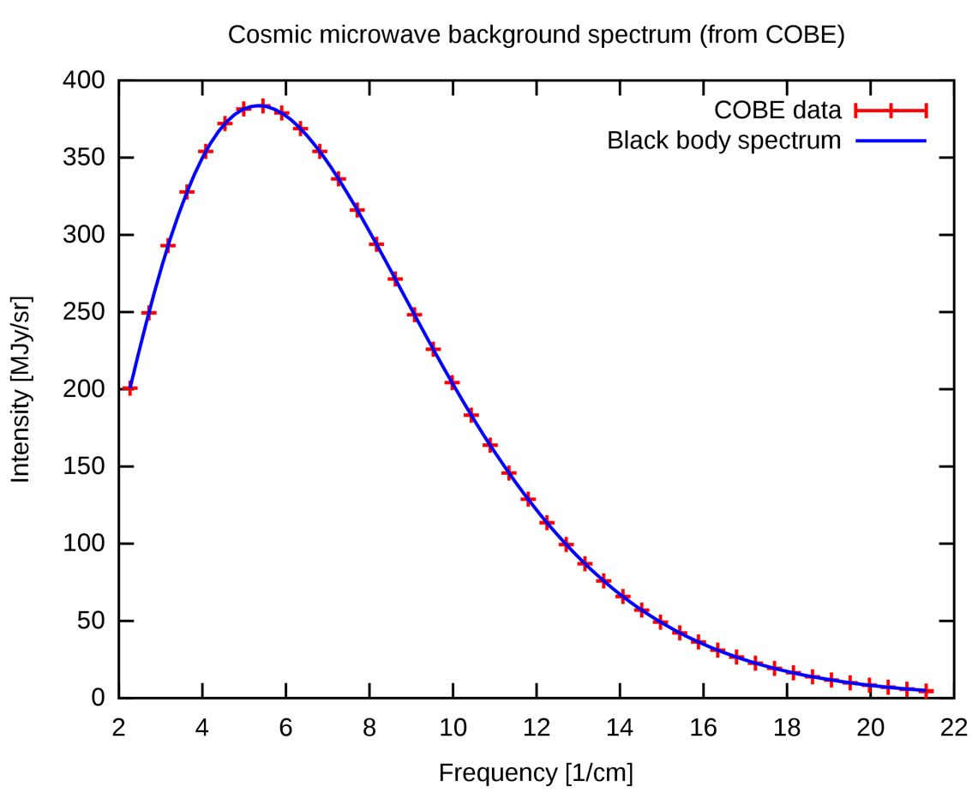

Doppler effect:

* Apparent change in frequency due to the relative movement between the sound source and the observer.
* When the sound source is moving towards the listener, the apparent frequency will be higher as more waves reach the listener per second.
* A lower frequency is heard when the sound source is receding as less waves reach the listener per second.



Red shift:

* The Doppler effect can be observed with light.
* When a light source is moving towards us, there’ll be an increase in the apparent frequency/colour of the light – this phenomenon is called blue shift.
* If the light source is moving away form us, there’s a decrease in apparent frequency/colour – this phenomenon is called red shift.
* The Doppler effect is used to determine if stars are moving away/towards us.
* Light from stars is analysed sing a spectroscope and the characteristic spectral lines are compared with those of known gases tested in the lab.
* All expected spectral lines move towards the red end of the spectrum → red shift e.g., from a close star.
* All expected spectral lines move towards the violet end of the spectrum → blue shift e.g., from a distant galaxy.

The red shift in the light from receding distant galaxies causes the frequency of the light to be reduced (wavelength is increased) and spectral lines are all closer to the red end of the spectrum.

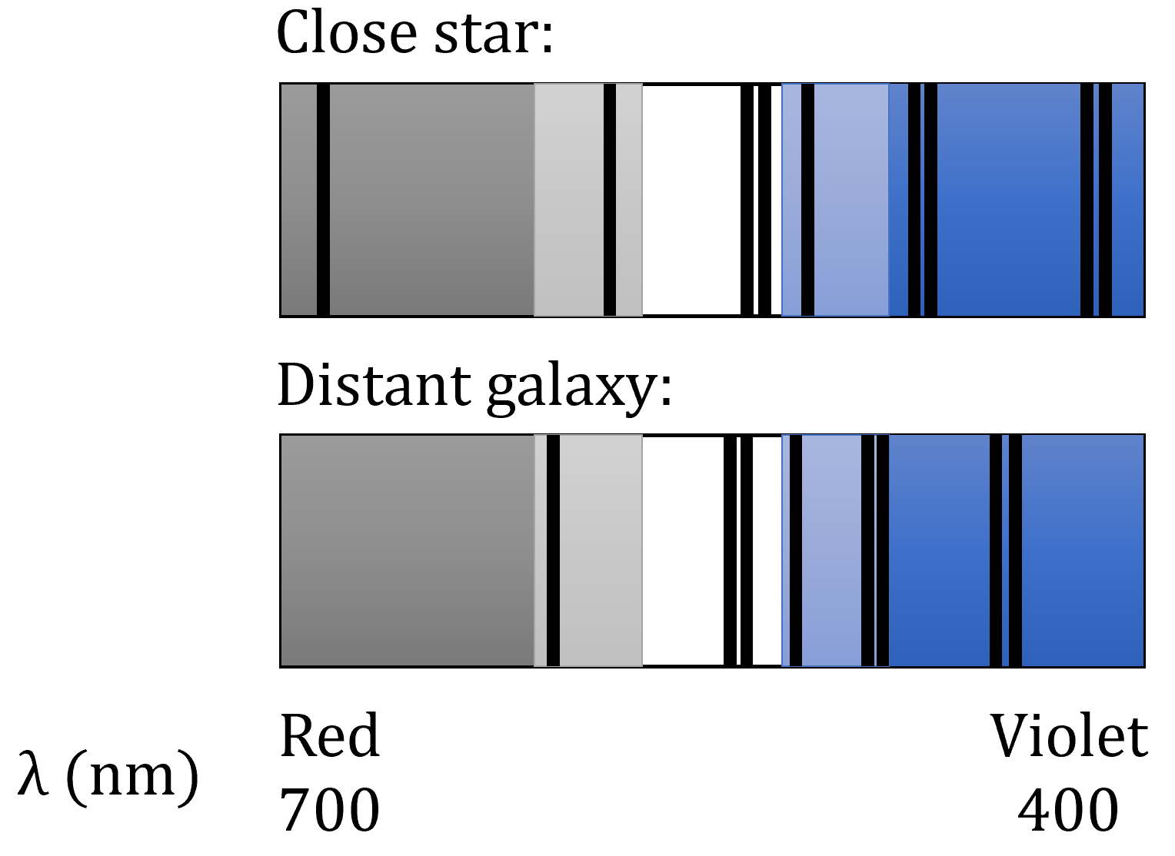

Hubble’s Law: The speed of recession of a galaxy is proportional to its distance from the Earth.

v = Hd where H is Hubble’s constant (2.29 x 10-18s-1).

The linear relationship holds well for distant galaxies but not for closer ones. The accurate measurement of distances to galaxies and the value of H is difficult. The value of $\frac{1}{H}$ is an indication of the age of the universe.

$$t=\frac{s}{v}$$

$$v=Hd→\frac{1}{v}=\frac{1}{Hd}$$

$$t=\frac{s}{Hd}=\frac{1}{H}$$

Astronomical unit (AU) – average distance from the Earth to the Sun (1.496 x 108km).

Light year – Distance travelled by light in a vacuum in one year (9.46 x 1012km).

Parsec (pc) – Distance to a star that’d have a parallax of 1 second arc ( $\frac{1}{3600}$ degrees) using the average distance from the Earth to the Sun as a baseline (3.086 x 1013km).

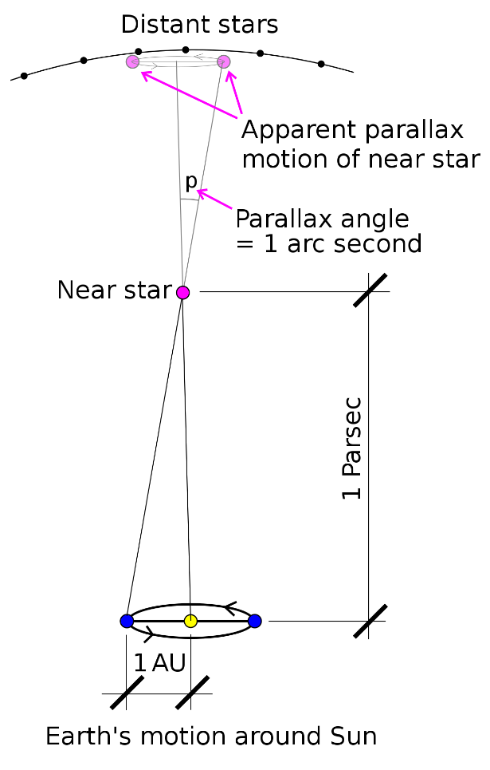



Electron gun:

* Consists of a low voltage heater element that allows electrons from a hot cathode to be accelerated to a high voltage anode.
* The cathode is coated with a metal that allows for the easy promotion of conduction electrons to its surface from which they’re literally boiled off as they’re attracted within the vacuum tune to the positive anode.
* The high-speed electron beam continues through the small hold in the anode to a CRT screen or where required.
* The electron beam in the CRO provides a beam of electrons which creates a white spot on the fluorescent screen. The beam direction can be controlled by voltages applied to the X and Y plates, thus creating a trace or picture on the screen.

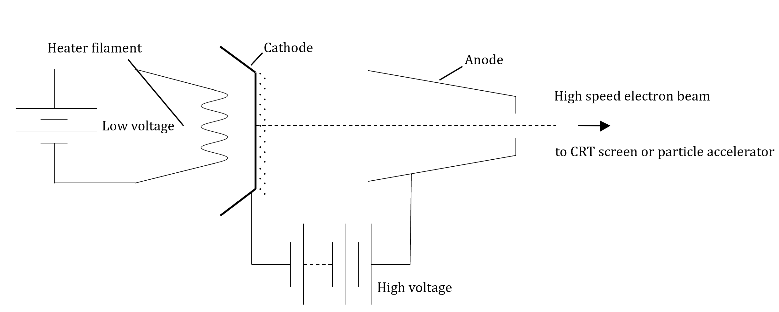

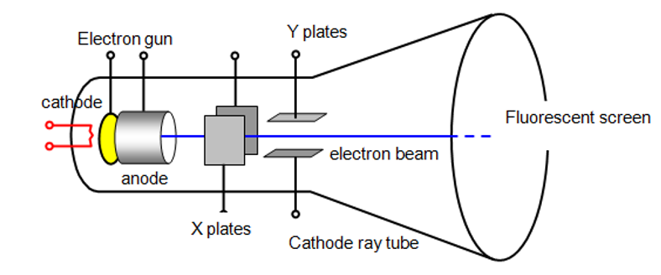

Linear accelerator (linac):

* Consists of a series of tubes through which electrons travel in a straight line.
* The tubes are connected to an alternating voltage which effectively creates a series of changing cathodes and anodes in the electron’s path.
* Voltage is alternated so that as the electrons leave one tube, the next in line becomes positive, attracting it, and the one it’s leaving becomes negative, repelling it.
* The acceleration of the electrons occurs as they accelerate from one tube to the next. They coast/drift while they’re within the tube.
* The length of each succeeding tube increases to match the increasing velocity of the electrons. This ensures that the change in polarity of the tubes due to the alternating voltage occurs exactly as they reachthe end of the tube.



* If you try to make the electron beam in the electron gun faster by supplying higher voltages, problems encountered include:

1. The practicality of using very high voltages on a single anode.
2. The relativistic effects that become dominant at speeds close to the speed of light.

Synchrotron:

* Accelerates electrons to velocities close to the speed of light which are made to travel in a circular path by the use of powerful magnets.
* The circular motion means the electrons are accelerating and this causes synchronous radiation to be emitted which is used for a wide range of research.

Main components of the synchrotron:

* Electron gun – Electrons are produced by emission from a hot tungsten cathode.
* Linear accelerator (linac) – Uses a series of radio frequency cavities to further accelerate the electrons to velocities greater than 0.9999c.
* Booster ring – A large circular device (130m in circumference) that boosts the energy of the electron beam. It contains a series of powerful magnets to keep the beam in circular motion and an RF cavity to provide energy.
* Storage ring – Where the beam is “stored” or allowed to circulate for many hours. This is a large device to allow sufficient curvature for the fast-moving beam. It consists of several straight sections followed by arcs (giving an overall circular shape) and at each arc powerful magnets are used to bend the electron beam. This is where the synchrotron light is produced.
* Beam lines and end-stations – The synchrotron light (radiation) is directed down long pipelines (called beam lines) to areas where research takes place. These areas are called end-stations and receive synchronous radiation of selected energies or wavelengths suitable for the particular investigation occurring.

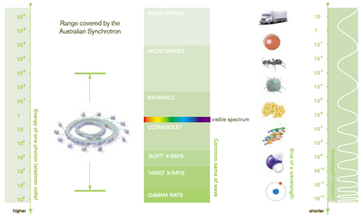

**Set 15.1**

**Q: How any fundamental particles make up the hundreds of known particles?**

6 quarks, 6 leptons, 6 antiquarks, 6 antileptons and the force carriers.

**Q: What are protons, neutrons and electrons made from?**

Protons and neutrons are made up of quarks which ae held together by gluons. Electrons are fundamental particles and are classified as leptons.

**Q: Baryons and mesons are made of quarks. Describe their makeup.**

Baryons and mesons are hadrons. Baryons are any hadron made of 3 quarks (qqq). Mesons are hadrons made from a quark and its anti-quark.

**Q: When a muon and an antimuon collide, they annihilate each other and release their mass-energy as 2 photons. Assuming that these 2 photons are identical:**

**[a] What will each of their energies be?**

Both muon and antimuon have a mass of 105.66MeV c-2. The 2 photons will each have energies of 105.66MeV.

**[b] What wavelengths will they have?**

E = hn = $\frac{hc}{l}$ → E = $\frac{hc}{E}$ = $\frac{{(6.63 x 10}^{–34} x 3 x {10}^{8}}{105.66 x {10}^{6} x 1.6 x {10}^{–19}}$ = 4.20 x 10–15m

**[c] Why does there need to be 2 photons produced and not just one?**

2 photons are required to conserve momentum.

**[d] In what directions would they have to travel relative to each other and why?**

They must travel in opposite directions to conserve momentum.

Example reactions:

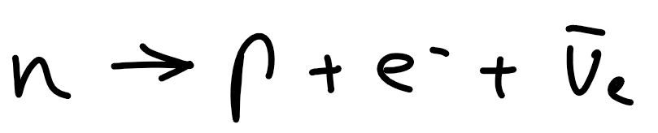

|  |  |  |  |
| --- | --- | --- | --- |
|  | Charge: | Baryon number: | Lepton number: |
| LHS | 0 | 1 | 0 |
| RHS | 0 | 1 | 1 |
| Balance | 0 | 0 | –1 |

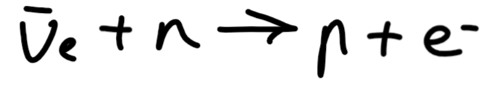

|  |  |  |  |
| --- | --- | --- | --- |
|  | Charge: | Baryon number: | Lepton number: |
| LHS | 0 | 1 | 0 |
| RHS | –1 | 0 | 1 |
| Balance | 1 | –1 | –1 |

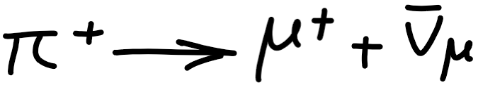

|  |  |  |  |
| --- | --- | --- | --- |
|  | Charge: | Baryon number: | Lepton number: |
| LHS | 1 | 0 | 0 |
| RHS | 1 | 0 | 1 |
| Balance | 0 | 0 | –1 |

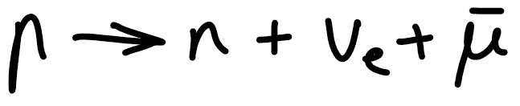

|  |  |  |  |
| --- | --- | --- | --- |
|  | Charge: | Baryon number: | Lepton number: |
| LHS | **0** | **1** | **1** |
| RHS | **1** | **1** | **0** |
| Balance | **1** | **0** | **–1** |

**Q: An electron and a positron undergo pair annihilation. If they initially had no kinetic energy, what’s the energy of each gamma ray produced by the annihilation? Why must there be 2 gamma rays produced?**

Each gamma ray must have energy of 511keV (the rest energy of an electron and positron). To conserve momentum, 2 gamma rays are produced travelling in opposite directions.

**Q: If a magnetic field makes electrons go clockwise, in what direction does it make positrons go?**

Anticlockwise.

**Q: Can an object accelerate while keeping the same speed?**

Yes if they’re undergoing circular motion at constant angular velocity.

**Q: An electron and a positron were produced when a particle and its antiparticle collided head-on, perpendicular to this page, The diagram below shows the outcome of the collision. What conservation law appears to have been broken? Explain.**

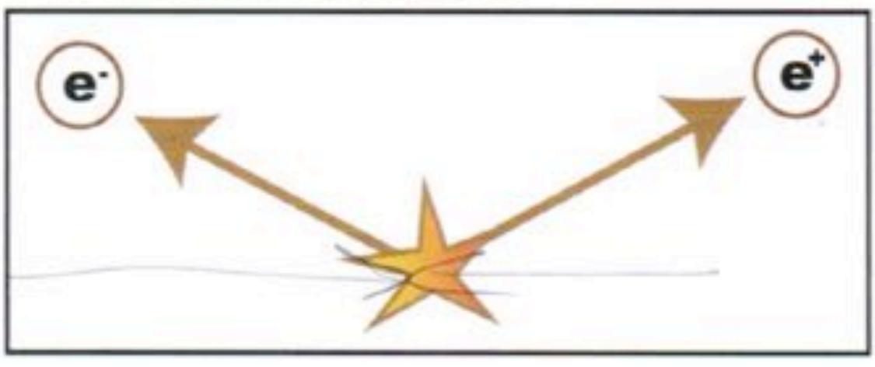

Conservation of momentum is violated. The particles have momentum towards the top of the page which they didn’t possess before the collision.

**Q: Which fundamental interaction is responsible for:**

**[a] Friction?**

Residual electromagnetic interactions between the atoms of the 2 materials. The force carriers are photons and W and Z bosons.

**[b] Nuclear bonding?**

Residual strong interactions between the various parts of the nucleus. The force carriers are gluons.

**[c] Planetary orbits?**

Planets orbit due to gravitons.

**Q: Which force carriers can’t be isolated? Why?**

Gluons can’t be isolated because they carry colour charge themselves.

**Q: Which force carriers haven’t been observed?**

Gravitons are hypothetical particles to explain the “force” of gravity.